Comp Sci 1

VISUAL BASIC

“Grade Calculator”

Worth 75 points

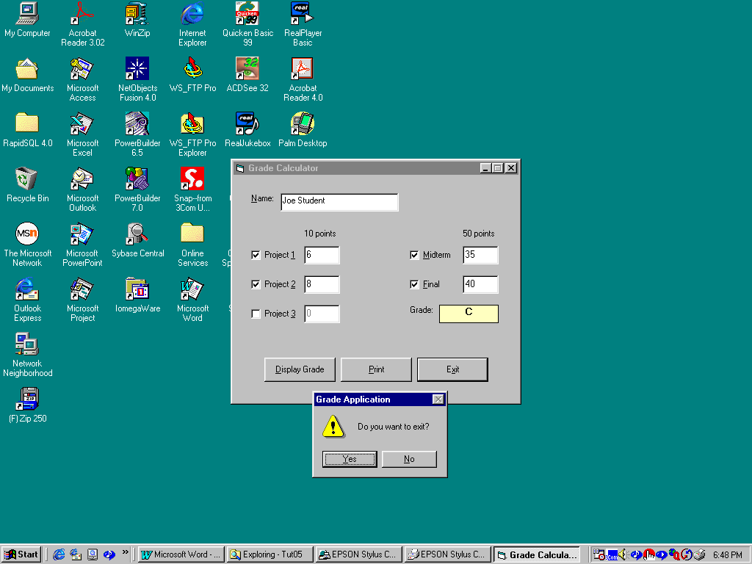

Objective: Create a project that calculates a student’s grade based on their
project and exam scores.

Project Description:

The program will allow the user to enter the Student’s name plus assignments and exam scores.

The program should work as follows:

Allow the user to enter the student’s name

Allow the user to select the projects and exams completed, then enter the associated grade, in numbers, for that assignment or exam.

Then allow the user to calculate a letter grade.

When the user attempts to exit the application, make sure they wish to exit the program.
Once the user enters the desired project and exam information and clicks on “display grade”, you need to determine the letter grade by summing the total points earned as follows:

A maximum of 10 points for each project

A maximum of 50 points for each exam.

Calculate a score ratio by dividing the total points earned by the total possible points. Assign the letter grade as follows:

GRADE RATIO
A >= .9
B >= .8
C >= .7
D >= .6
F lower that .6

You need to use arraylist, linking to one subroutine and repetitive loops to gain the maximum points.

Hints:

Control Arrays will make the program easier.

The WAY you code the solution counts as much as getting the project to work. You need to use control arrays, loops and select case statements in your solution.

